Calculus 1 Lecture 0.3: Review of Trigonometry and Graphing Trigonometric Functions
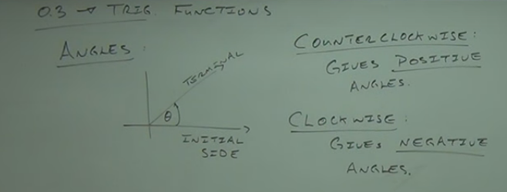

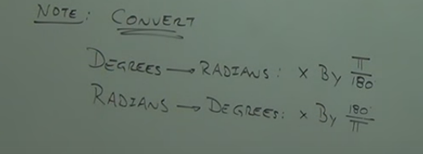

Example
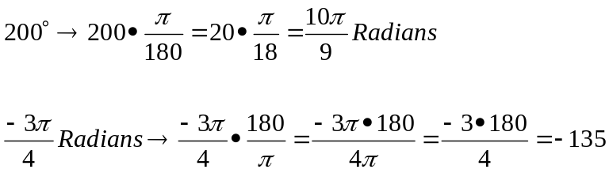

Example
Graph the angle

E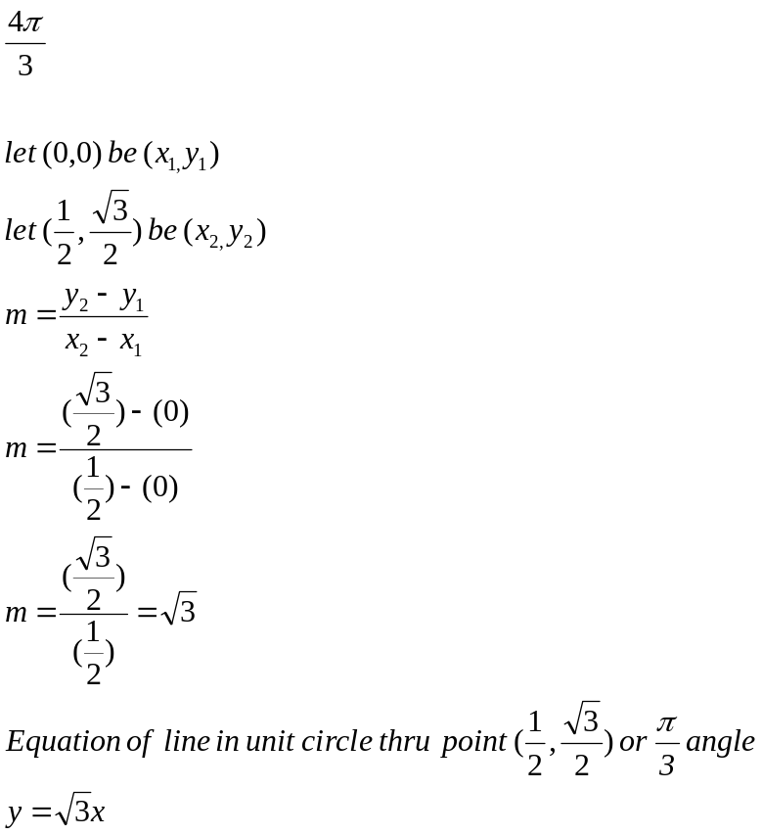

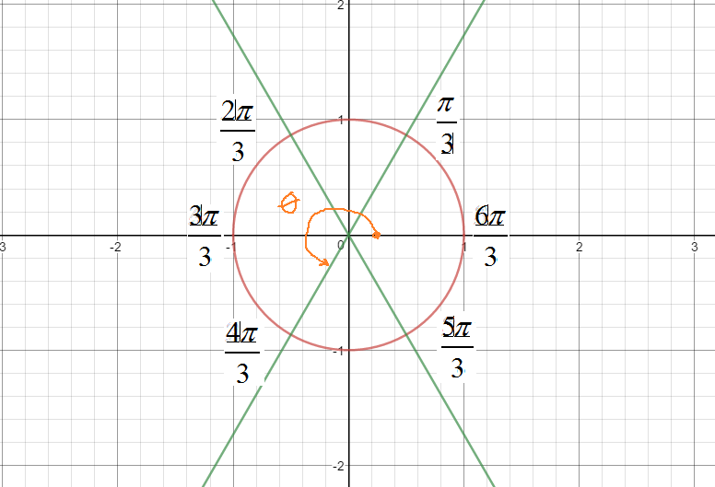

Example
Graph the angle
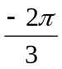

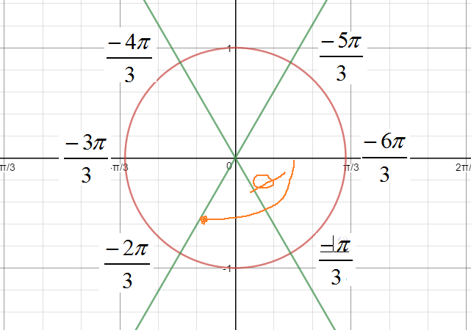

Example
Graph the angle
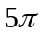

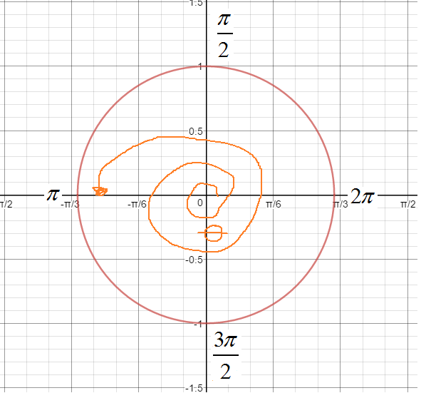
Example
Graph the angle
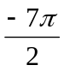

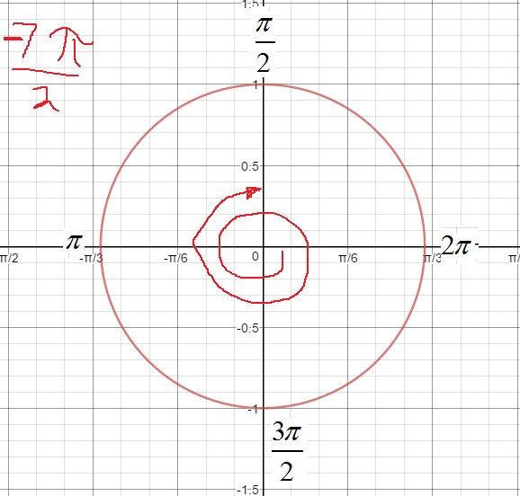

Trig functions:

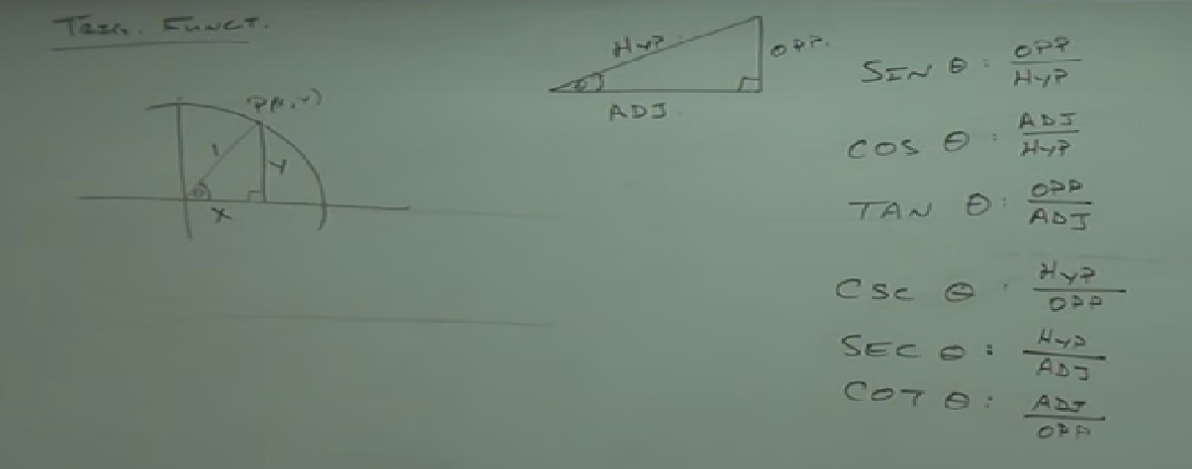

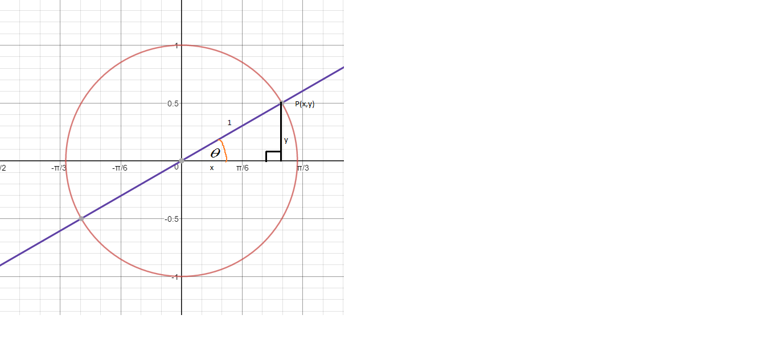
Soh-cah-toa

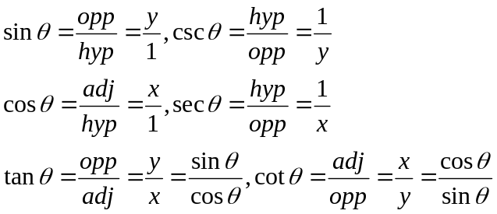

Astc--All Students take calculus

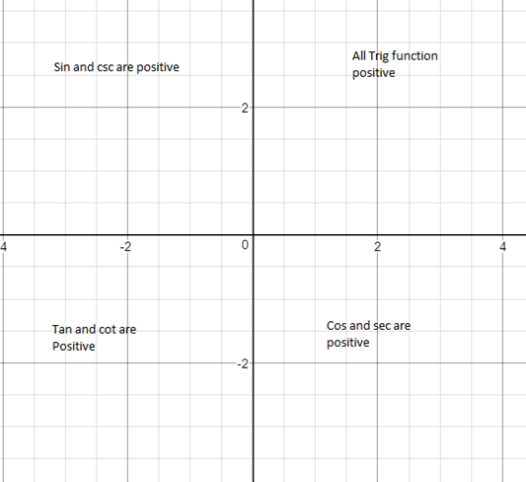

Reference Angles

Idea: Make an acute angle with the x-axis, the use ASTC

First quadrant reference angle

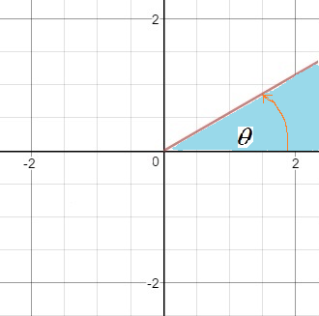

Reference angle is

Second quadrant reference angle

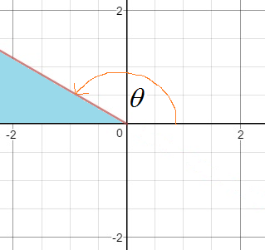

Reference Angle is 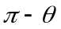

Third quadrant reference angle

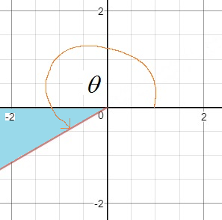
Reference angle is 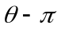

Forurth quadrant reference angle

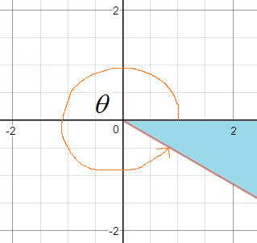

Reference angle is 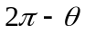

Steps in using Reference angle
- Locate quadrant (graph) of angle
- Find Reference angle
- Find trig function of reference angle

Example
Find sin, cos, tan of 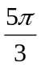
Graph
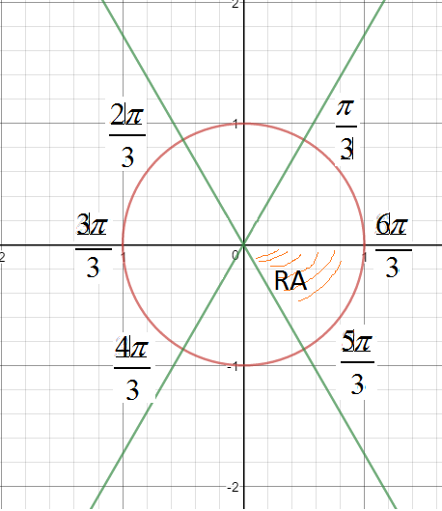
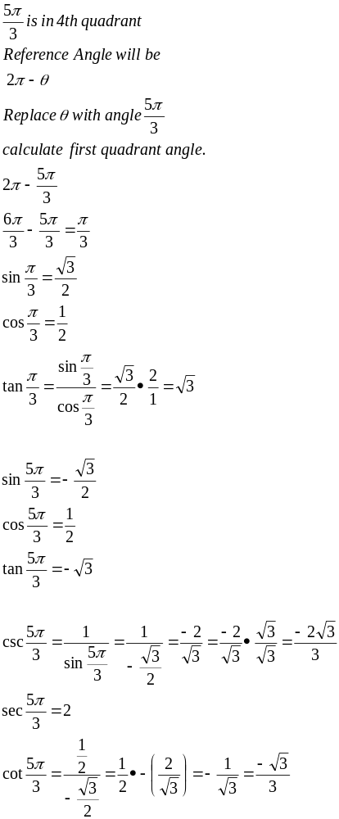

Graph:
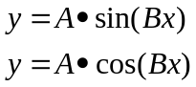
|A| is amplitude of wave
|B| is period (frequency) of wave

Midpoint of period is where the graph comes back to the x-axis
The midpoints of where the graph cross the x-axis are the peaks and valleys of the graph

Example
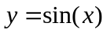
Amplitude s 1
Period =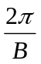
Points of interest on graph is period divided by 4
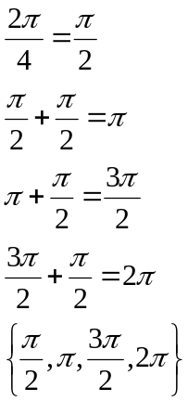

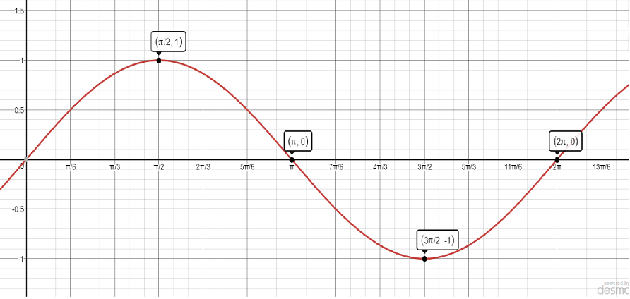

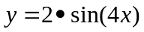
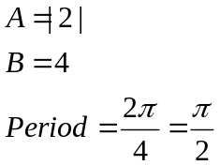

Points of interest on graph is period divided by 4

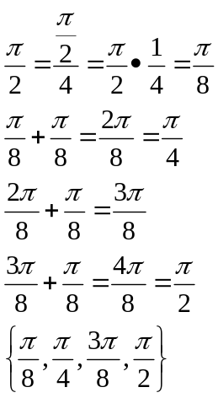

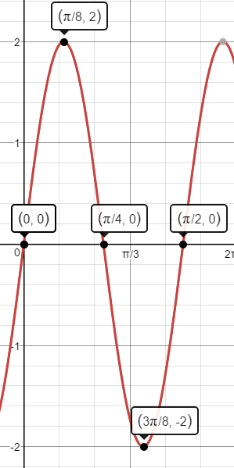

Example
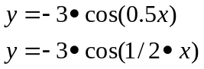
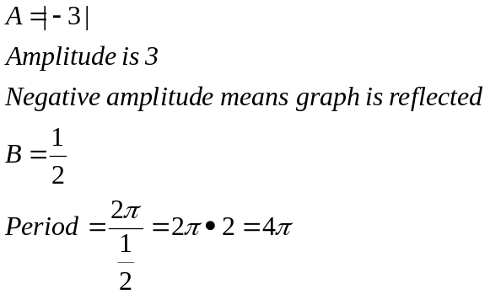

Points of interest on graph is period divided by 4

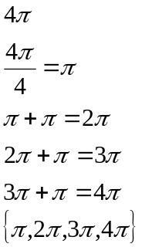

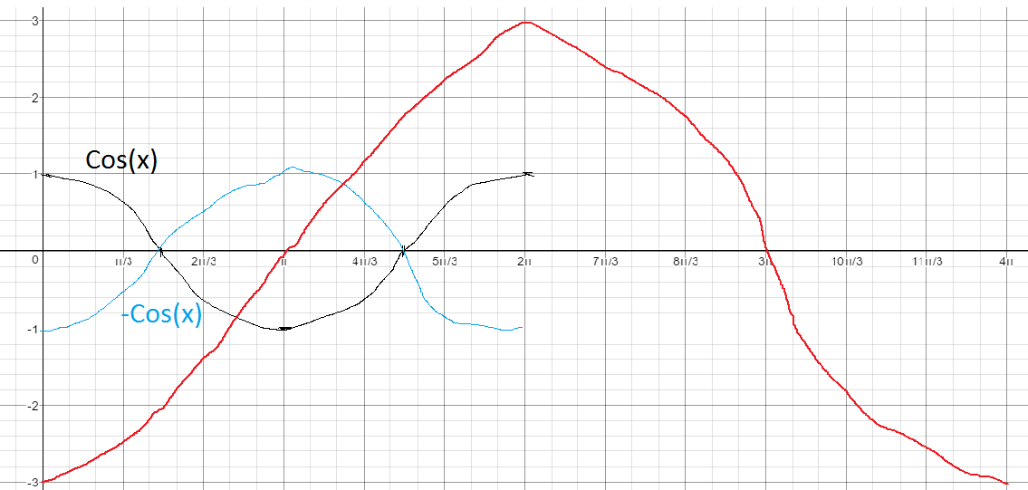

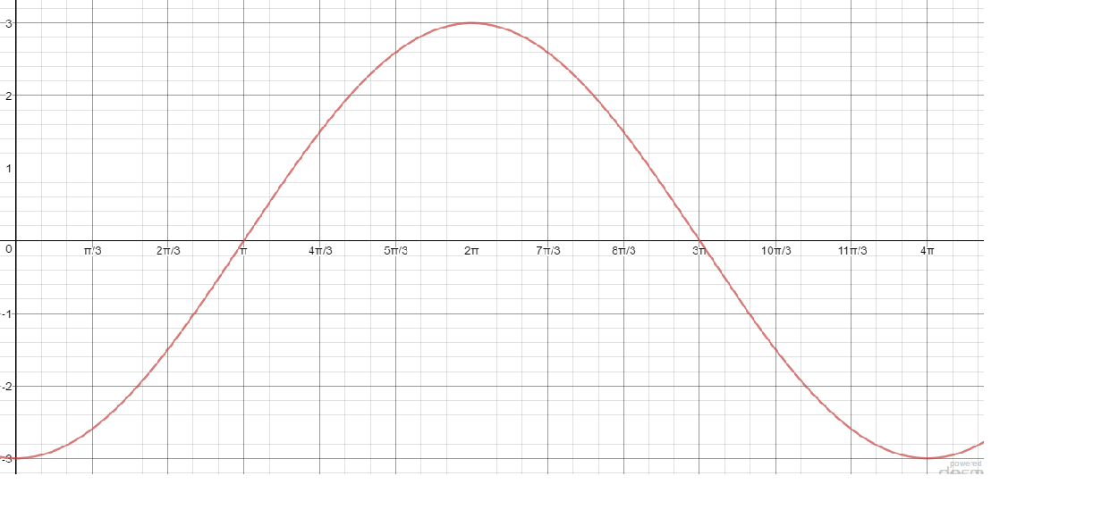

Graph: sin and cos graphs with shift along x-axis
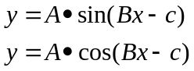

To find the shift you have to factor b out of equation by force
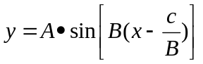
The c/b is the Translation (shift) along the x-axis
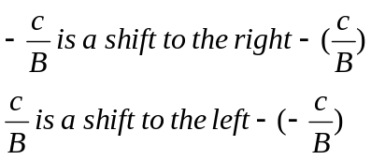

Example
